Right Pyramid

Definition
# Source: AI Source: Provided by: [Data Path: Persons Table -> ID Column: 1, Name_En Column: Motasem Essam] -> From: [ChatGPT] on [7/25/2026]
A right pyramid is a three-dimensional geometric solid in which the perpendicular from the apex meets the base at the base's center, according to the conventional definition used for regular or suitably centered bases.
For a regular polygonal base, the apex lies directly above the center of the base. The altitude is therefore perpendicular to the base plane and passes through its center.
A right pyramid may have a triangular, quadrilateral, pentagonal, hexagonal, or other polygonal base. The term right describes the position of the apex relative to the base; it does not specify the number of sides of the base.
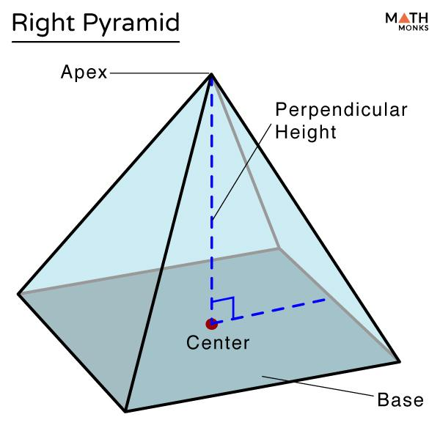
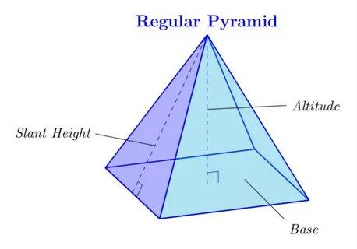
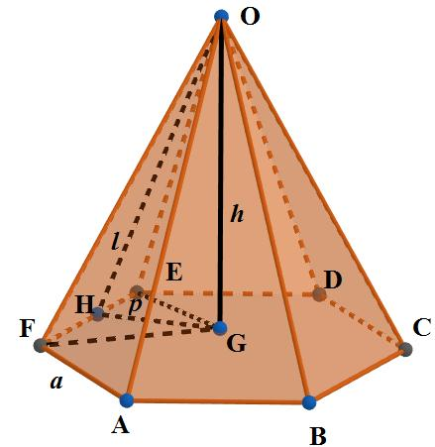

Simple Definition
# Source: AI Source: Provided by: [Data Path: Persons Table -> ID Column: 1, Name_En Column: Motasem Essam] -> From: [ChatGPT] on [7/25/2026]
A right pyramid is a pyramid whose apex is directly above the center of its base, so the perpendicular height falls at that center.
For a regular right pyramid, the base is a regular polygon and the lateral faces are congruent isosceles triangles.

Classification Tree
# Source: AI Source: Provided by: [Data Path: Persons Table -> ID Column: 1, Name_En Column: Motasem Essam] -> From: [ChatGPT] on [7/25/2026]
Pyramids by Spatial Orientation
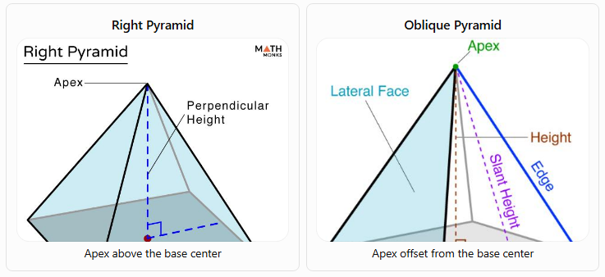
Right Pyramid
Apex above the base center
Oblique Pyramid
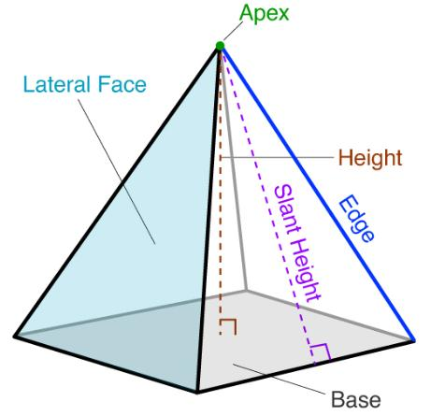
Apex offset from the base center
A. By Base Shape
A right pyramid can be classified according to its base polygon:
- Right triangular pyramid
- Right quadrilateral pyramid
- Right pentagonal pyramid
- Right hexagonal pyramid
- Right $n$-gonal pyramid
B. By Base Regularity
- Regular right pyramid: Has a regular polygonal base, with the apex directly above its center. Its lateral faces are congruent isosceles triangles.
- Right pyramid with an irregular base: Has an irregular polygonal base, with the perpendicular from the apex meeting the designated base center. The lateral faces need not be congruent. The term center must be defined carefully for an irregular polygon, since some irregular polygons do not have a unique natural center.

Key Characteristics
# Source: AI Source: Provided by: [Data Path: Persons Table -> ID Column: 1, Name_En Column: Motasem Essam] -> From: [ChatGPT] on [7/25/2026]
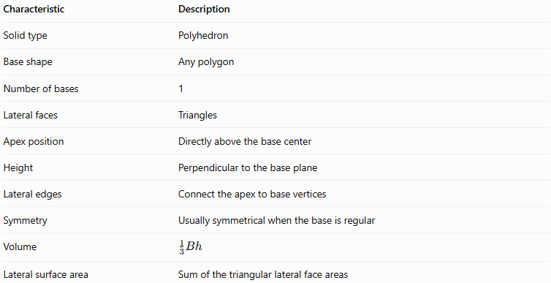
Characteristic | Description
Solid type | Polyhedron
Base shape | Any polygon
Number of bases | 1
Lateral faces | Triangles
Apex position | Directly above the base center
Height | Perpendicular to the base plane
Lateral edges | Connect the apex to base vertices
Symmetry | Usually symmetrical when the base is regular
Volume | $$\frac{1}{3}Bh$$
Lateral surface area | Sum of the triangular lateral face areas
The number of faces, edges, and vertices depends on the number of sides $n$ in the base:
$$F=n+1, E=2n, V_{e}=n+1$$

Geometric Representation
# Source: AI Source: Provided by: [Data Path: Persons Table -> ID Column: 1, Name_En Column: Motasem Essam] -> From: [ChatGPT] on [7/25/2026]
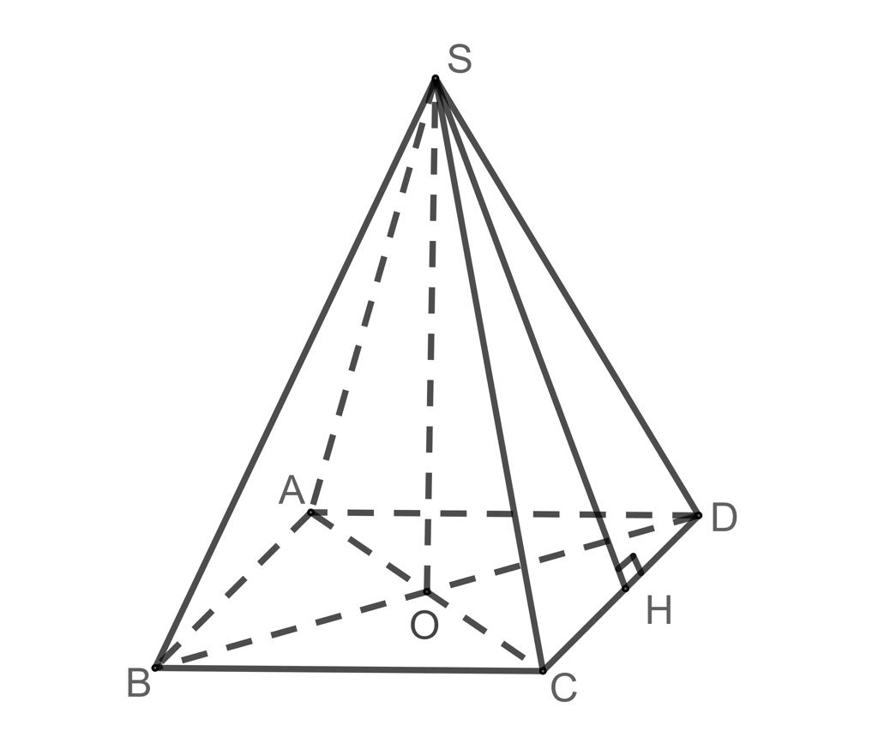
Consider a square-based right pyramid with apex $S$, base $ABCD$, and base center $O$.
Its main components are:
- Base $ABCD$: The polygon forming the bottom face.
- Apex $S$: The vertex above the base center.
- Height $SO$: The perpendicular distance from the apex to the base plane.
- Base edges: $AB,BC,CD,$ and $DA$.
- Lateral edges: $SA,SB,SC,$ and $SD$.
- Lateral faces: Triangles $SAB,SBC,SCD,$ and $SDA$.
- Slant height $l$: For a regular right pyramid, the perpendicular distance from the apex to the midpoint of a base edge, measured along a lateral face.
Important distinction: The height is measured perpendicular to the base plane. The slant height is measured along a lateral face. They are generally not equal.

Mathematical Representations and Formulas
# Source: AI Source: Provided by: [Data Path: Persons Table -> ID Column: 1, Name_En Column: Motasem Essam] -> From: [ChatGPT] on [7/25/2026]
Let:
- $B$ = base area
- $p$ = base perimeter
- $h$ = perpendicular height
- $l$ = slant height of a regular right pyramid
- $r$ = apothem of a regular polygonal base
- $a$ = side length of a regular polygonal base

A. Volume
# Source: AI Source: Provided by: [Data Path: Persons Table -> ID Column: 1, Name_En Column: Motasem Essam] -> From: [ChatGPT] on [7/25/2026]
The volume of any pyramid, including a right pyramid, is:
$$\boxed{V=\frac{1}{3}Bh}$$
The right-pyramid orientation does not change the volume formula.

B. Lateral surface area
# Source: AI Source: Provided by: [Data Path: Persons Table -> ID Column: 1, Name_En Column: Motasem Essam] -> From: [ChatGPT] on [7/25/2026]
For any pyramid, the lateral surface area is the sum of the areas of its triangular lateral faces:
$$A_{L}=\sum_{i=1}^{n}{A_{i}}$$
For a regular right pyramid, all lateral faces have the same slant height, so:
$$\boxed{A_{L}=\frac{1}{2}pl}$$
This simplified formula should not be applied automatically to every right pyramid with an irregular base.

C. Total surface area
# Source: AI Source: Provided by: [Data Path: Persons Table -> ID Column: 1, Name_En Column: Motasem Essam] -> From: [ChatGPT] on [7/25/2026]
$$\boxed{A_{T}=B+A_{L}}$$
For a regular right pyramid:
$$\boxed{A_{T}=B+\frac{1}{2}pl}$$

D. Relationship between height and slant height
# Source: AI Source: Provided by: [Data Path: Persons Table -> ID Column: 1, Name_En Column: Motasem Essam] -> From: [ChatGPT] on [7/25/2026]
For a regular right pyramid, the height, base apothem, and face slant height form a right triangle:
$$\boxed{l=\sqrt{h^{2}+r^{2}}}$$
Rearranging to find the perpendicular height:
$$\boxed{h=\sqrt{l^{2}-r^{2}}}$$
These formulas use the base apothem, not the base circumradius, because the slant height ends at the midpoint of a base edge.

E. Lateral edge length
# Source: AI Source: Provided by: [Data Path: Persons Table -> ID Column: 1, Name_En Column: Motasem Essam] -> From: [ChatGPT] on [7/25/2026]
For a regular right pyramid, let $R$ be the circumradius of its base, the distance from the base center to a base vertex. If $e$ is the length of a lateral edge:
$$\boxed{e=\sqrt{h^{2}+R^{2}}}$$
The lateral edge and the face slant height are different measurements.

Worked Examples
# Source: AI Source: Provided by: [Data Path: Persons Table -> ID Column: 1, Name_En Column: Motasem Essam] -> From: [ChatGPT] on [7/25/2026]
Example 1: Calculating volume
Problem: A right pyramid has a base area of $64{\text{ cm}}^{2}$ and a perpendicular height of $9\text{ cm}$. Find its volume.
Solution:
$$V=\frac{1}{3}Bh$$
$$V=\frac{1}{3}\left(64\right)\left(9\right)$$
$$\boxed{V=192{\text{ cm}}^{3}}$$
Example 2: Finding the slant height
Problem: A regular right square pyramid has a base side length of $6\text{ cm}$ and a perpendicular height of $4\text{ cm}$. Find its slant height.
Solution:
The apothem of a square is half its side length:
$$r=\frac{6}{2}=3\text{ cm}$$
Using the slant-height formula:
$$l=\sqrt{h^{2}+r^{2}}$$
$$l=\sqrt{4^{2}+3^{2}}=\sqrt{25}$$
$$\boxed{l=5\text{ cm}}$$
Example 3: Calculating lateral surface area
Problem: A regular right square pyramid has a base side length of $8\text{ cm}$ and a slant height of $5\text{ cm}$. Find its lateral surface area.
Solution:
First, calculate the base perimeter:
$$p=4\left(8\right)=32\text{ cm}$$
Then:
$$A_{L}=\frac{1}{2}pl$$
$$A_{L}=\frac{1}{2}\left(32\right)\left(5\right)$$
$$\boxed{A_{L}=80{\text{ cm}}^{2}}$$
Example 4: Calculating total surface area
Using the same pyramid from Example 3, calculate the total surface area.
The square base area is:
$$B=8^{2}=64{\text{ cm}}^{2}$$
The lateral surface area is $80{\text{ cm}}^{2}$.
$$A_{T}=B+A_{L}$$
$$A_{T}=64+80$$
$$\boxed{A_{T}=144{\text{ cm}}^{2}}$$
Example 5: Counting faces, edges, and vertices
Problem: Find the number of faces, edges, and vertices of a right hexagonal pyramid.
Since the base has six sides, $n=6$:
$$F=n+1=7$$
$$E=2n=12$$
$$V_{e}=n+1=7$$
Answer: 7 faces, 12 edges, and 7 vertices.

Comparison with Related Types of Pyramids
# Source: AI Source: Provided by: [Data Path: Persons Table -> ID Column: 1, Name_En Column: Motasem Essam] -> From: [ChatGPT] on [7/25/2026]
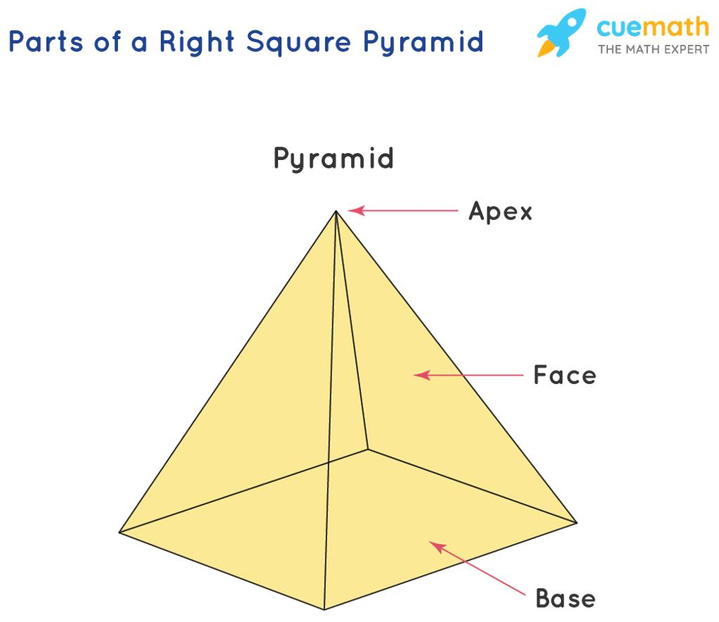
Right Pyramid
- Apex is directly above the base center.
- Height is perpendicular to the base plane.
- For a regular base, lateral faces are congruent.
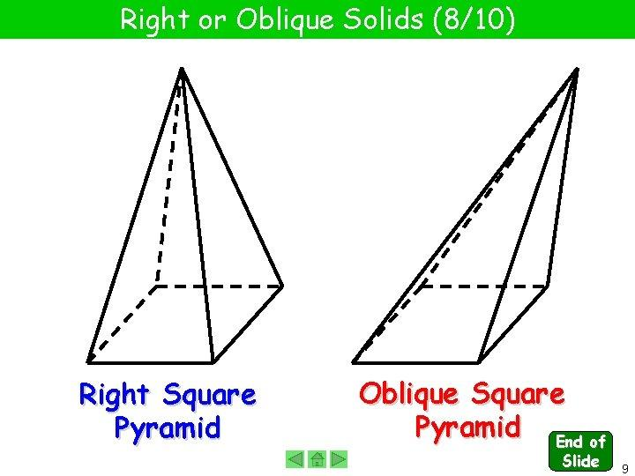
Oblique Pyramid
- Apex is offset from the base center.
- Lateral faces generally differ in shape or size.
- Volume is still $\frac{1}{3}Bh$.
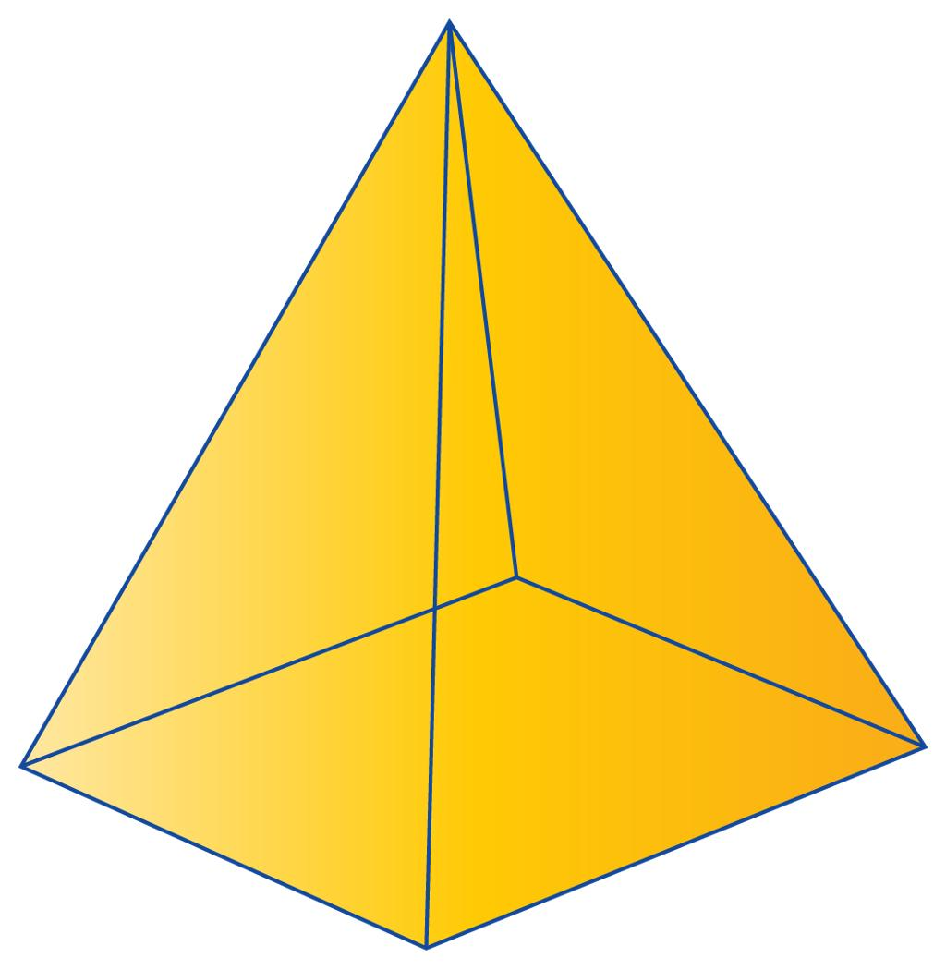
Regular Pyramid
- Has a regular polygonal base.
- Apex lies above the base center.
- Lateral faces are congruent isosceles triangles.
- It is a special type of right pyramid.

Applications
# Source: AI Source: Provided by: [Data Path: Persons Table -> ID Column: 1, Name_En Column: Motasem Essam] -> From: [ChatGPT] on [7/25/2026]
Right pyramids are useful in:
- Architecture: Pyramid-shaped roofs and monuments with symmetrical footprints.
- Engineering: Modeling tapered structures and calculating their material requirements.
- Computer graphics: Creating symmetrical polygon-based 3D models.
- Mathematics education: Understanding perpendicular height, slant height, surface area, and volume.
- Design: Developing decorative structures and objects with regular polygonal bases.

Key Points
# Source: AI Source: Provided by: [Data Path: Persons Table -> ID Column: 1, Name_En Column: Motasem Essam] -> From: [ChatGPT] on [7/25/2026]
- A right pyramid is classified by the position of its apex relative to the base.
- Its perpendicular height meets the base at the center under the conventional definition.
- A regular right pyramid has a regular polygonal base and congruent lateral faces.
- The volume is $V=\frac{1}{3}Bh$.
- For a regular right pyramid, the lateral surface area is $A_{L}=\frac{1}{2}pl$.
- The slant height and perpendicular height are different measurements.
- A right pyramid can have any polygonal base with at least three sides.

Conclusion
# Source: AI Source: Provided by: [Data Path: Persons Table -> ID Column: 1, Name_En Column: Motasem Essam] -> From: [ChatGPT] on [7/25/2026]
A right pyramid is a pyramid whose apex lies directly above the center of its base, making its altitude perpendicular to the base plane. This arrangement distinguishes it from an oblique pyramid. When the base is a regular polygon, the solid has a symmetrical structure and simpler surface-area calculations. Understanding the position of the apex, the perpendicular height, and the slant height is essential for classifying right pyramids and solving related geometric problems.

